AUTHORIZATION AGREEMENT FOR AUTOMATIC DEPOSITS (ACH CREDITS)

Employee Information/Authorization:

Employee Name (Please Print) Social Security Number

I authorize and request my employer to deposit my pay automatically to my account identified below each payday. This authorization will remain in effect unless canceled in writing. I understand that a pre-note must be initiated at least ten (10) days in advance of my first payroll deposit.

(Select One)
Checking Amount
Savings Remainder Name of Financial Institution

Bank Routing No. Account No.

**************************************************************************************************
(Select One)
Checking Amount
Savings Remainder Name of Financial Institution

Bank Routing No. Account No.

Employee Signature Date

*Please attach a voided check or a copy of a voided check.*
Return to: Augustana College Payroll - 639 38th Street, Rock Island, IL 61201
**************************************************************************************************

Cancellation Statement:
I request that my employer terminate my authorized direct deposit of new amount due from payroll to my account. I allow a reasonable time for my employer to act upon my request to terminate this agreement.

Employee Signature Date

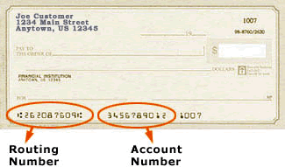 Revised 11/13

