Did you know that chronic diseases are associated with hearing loss and/or tinnitus? That means you can be more susceptible to experiencing hearing loss and/or tinnitus if you have one or more of the following conditions.
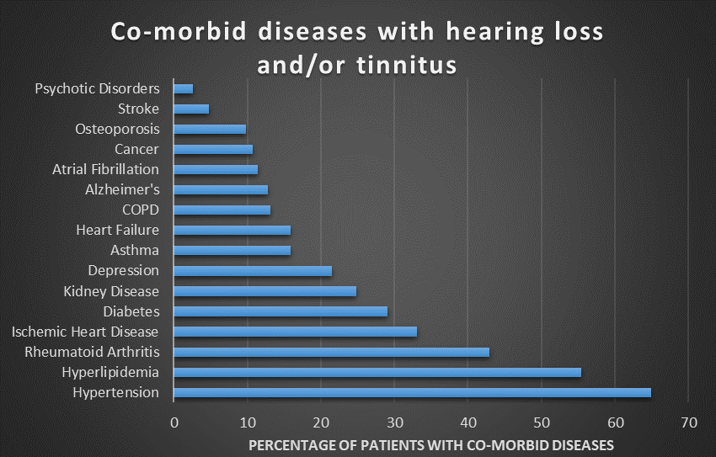
(Source: Traynor, R.M., & Hall, J.W. (2019). Competing in the New Era of Hearing Healthcare, Hearing Review)

Further, if you have hearing loss and it goes untreated, there are many consequences:

- Depression
- Irritability, anger
- Misunderstanding
- Social Isolation
- Poor Health
- Decreased Physical Activity
- Unemployment
- Loss of Productivity
- Cognitive Decline (Dementia)

Consider the following steps for good hearing health:
- Similar to yearly eye exams, have your hearing tested every year
- Share hearing test results with your physicians so care is coordinated
- Get fit with hearing aids! Hearing aids can reverse the negative consequences of hearing loss
- Use hearing protection regularly when exposed to loud sounds (social events, yard working, snow removal, etc.). There are many options available including disposable ear plugs, ear muffs, or have us make you custom made musician ear plugs.

